Regular Tessellation
# Source: AI Source: Provided by: [Data Path: Persons Table -> ID Column: 1, Name_En Column: Motasem Essam] -> From: [ChatGPT] on [7/25/2026]
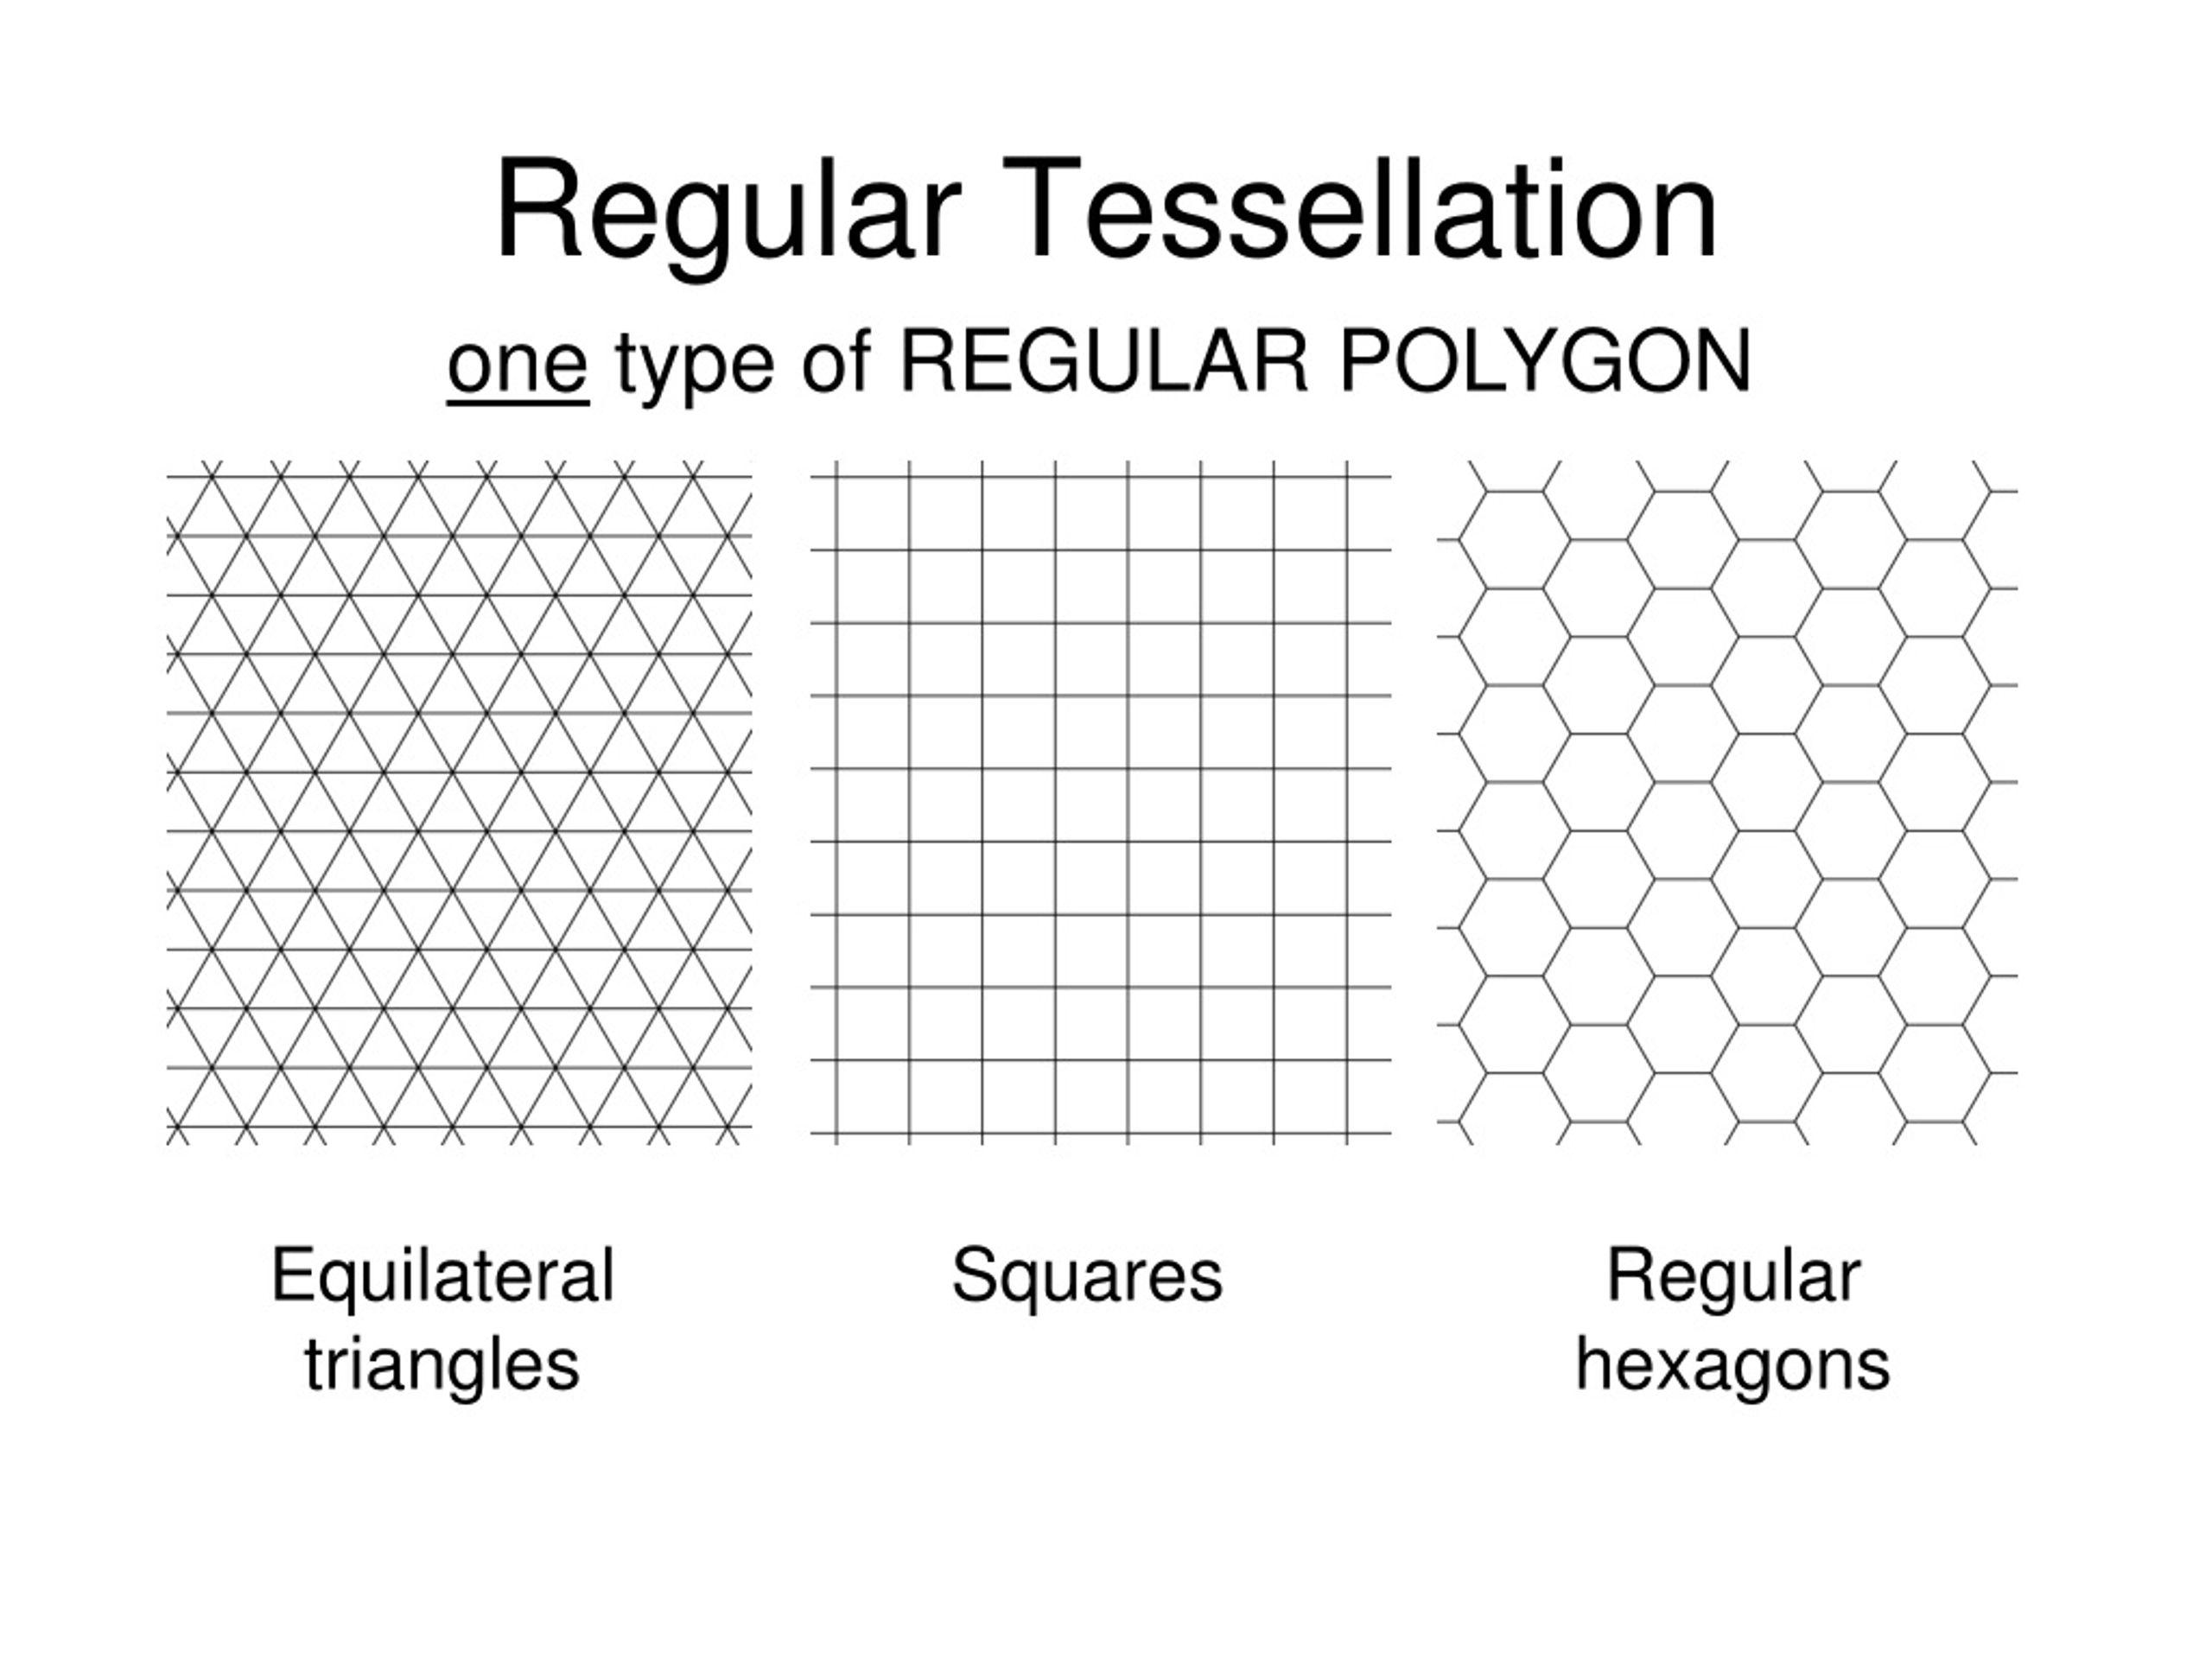
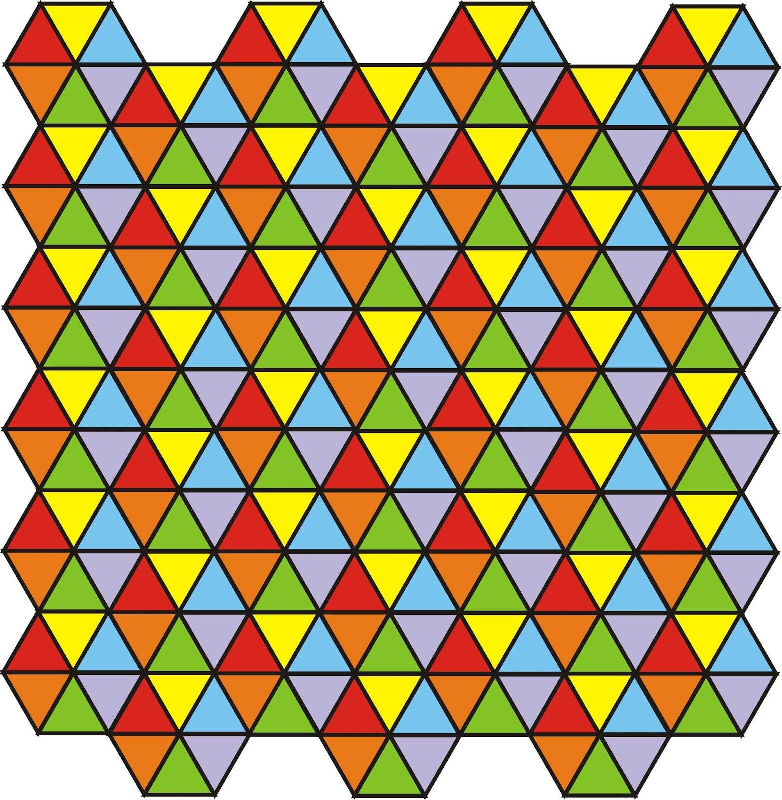
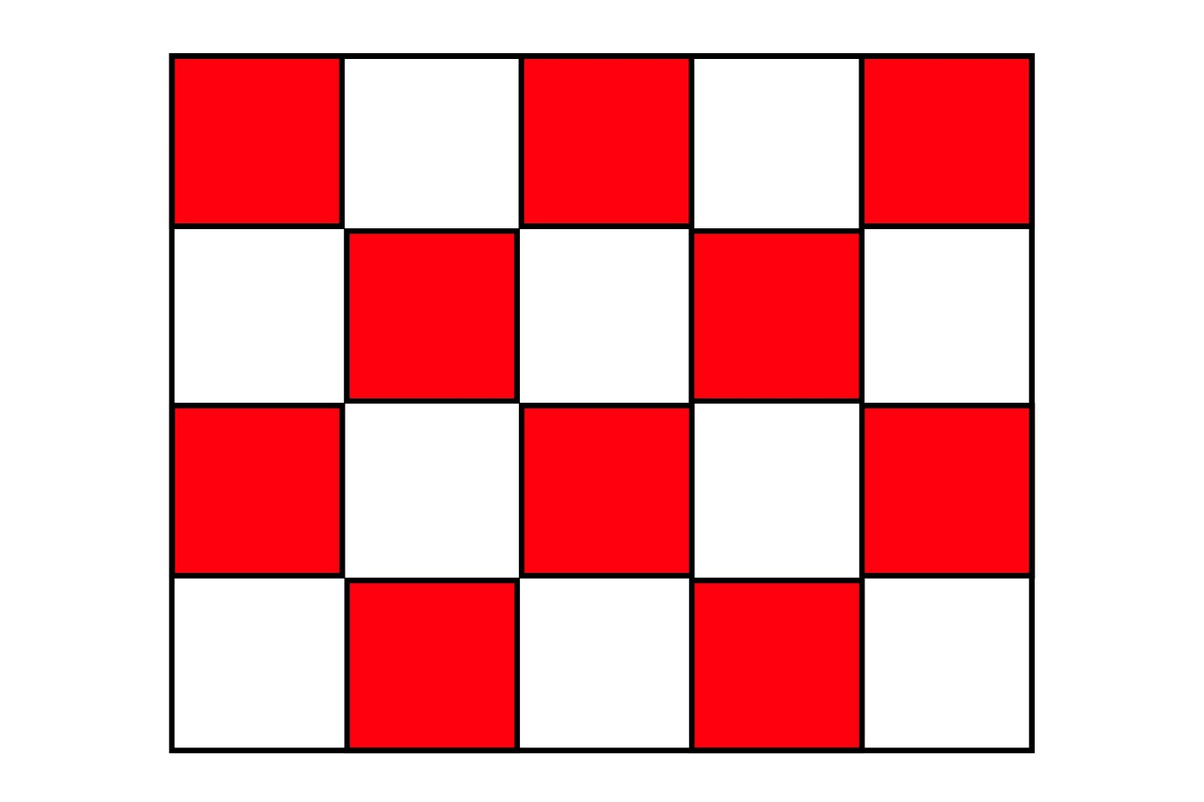
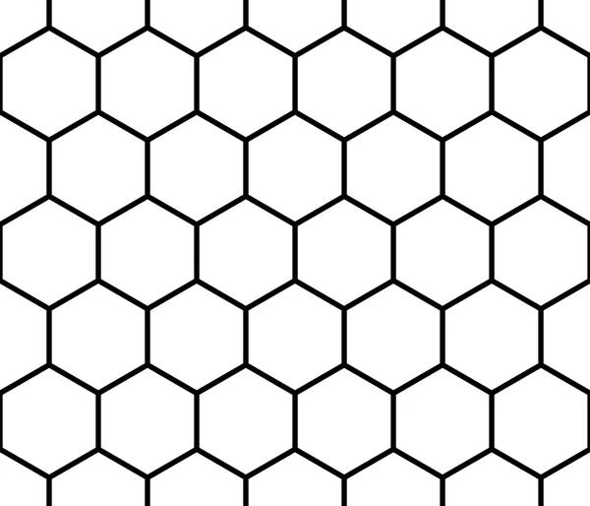

Definition
# Source: AI Source: Provided by: [Data Path: Persons Table -> ID Column: 1, Name_En Column: Motasem Essam] -> From: [ChatGPT] on [7/25/2026]
A Regular Tessellation is a tessellation of the Euclidean plane formed using only one type of regular polygon, with the same regular polygon meeting in the same way at every vertex.
A regular tessellation must satisfy two conditions:
- It uses only one type of regular polygon.
- The polygons completely cover the plane without gaps or overlaps.
At every vertex, the interior angles of the polygons must add to:
$$\boxed{{360}^{∘}}$$

Purpose
# Source: AI Source: Provided by: [Data Path: Persons Table -> ID Column: 1, Name_En Column: Motasem Essam] -> From: [ChatGPT] on [7/25/2026]
Regular tessellations are used to:
- Determine which regular polygons can tile a plane.
- Study the relationship between polygon angles and tessellation.
- Analyze symmetry and repeating geometric patterns.
- Provide the foundation for studying semi-regular and other tessellations.

Fundamental Elements

1. Regular Polygon
# Source: AI Source: Provided by: [Data Path: Persons Table -> ID Column: 1, Name_En Column: Motasem Essam] -> From: [ChatGPT] on [7/25/2026]
The tile must be a regular polygon, meaning:
- All sides are equal.
- All interior angles are equal.

2. Tile
# Source: AI Source: Provided by: [Data Path: Persons Table -> ID Column: 1, Name_En Column: Motasem Essam] -> From: [ChatGPT] on [7/25/2026]
Each repeated regular polygon is a tile.

3. Vertex
# Source: AI Source: Provided by: [Data Path: Persons Table -> ID Column: 1, Name_En Column: Motasem Essam] -> From: [ChatGPT] on [7/25/2026]
A tessellation vertex is a point where the polygons meet.

4. Interior Angle
# Source: AI Source: Provided by: [Data Path: Persons Table -> ID Column: 1, Name_En Column: Motasem Essam] -> From: [ChatGPT] on [7/25/2026]
If the regular polygon has $n$sides, each interior angle is:
$$\boxed{θ=\frac{\left(n-2\right){180}^{∘}}{n}}$$

5. Vertex Condition
# Source: AI Source: Provided by: [Data Path: Persons Table -> ID Column: 1, Name_En Column: Motasem Essam] -> From: [ChatGPT] on [7/25/2026]
If $k$identical regular polygons meet at a vertex:
$$\boxed{kθ={360}^{∘}}$$

The Three Regular Tessellations
# Source: AI Source: Provided by: [Data Path: Persons Table -> ID Column: 1, Name_En Column: Motasem Essam] -> From: [ChatGPT] on [7/25/2026]
There are exactly three regular tessellations of the Euclidean plane.
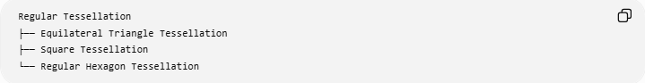
Regular Tessellation
├── Equilateral Triangle Tessellation
├── Square Tessellation
└── Regular Hexagon Tessellation

1. Equilateral Triangle Tessellation
# Source: AI Source: Provided by: [Data Path: Persons Table -> ID Column: 1, Name_En Column: Motasem Essam] -> From: [ChatGPT] on [7/25/2026]
An Equilateral Triangle Tessellation consists entirely of congruent equilateral triangles.
Each triangle has interior angles of:
$${60}^{∘}$$
Six triangles meet at every vertex:
$$6\left({60}^{∘}\right)={360}^{∘}$$
Therefore, the triangles completely cover the plane.
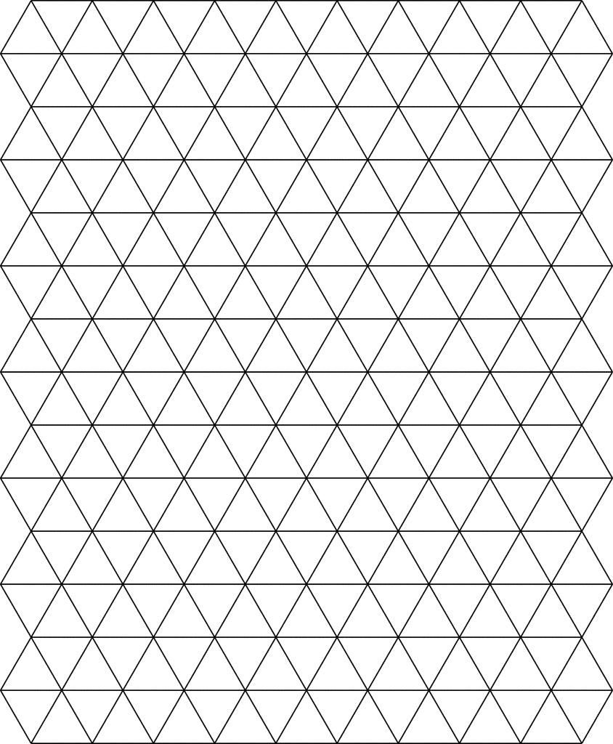
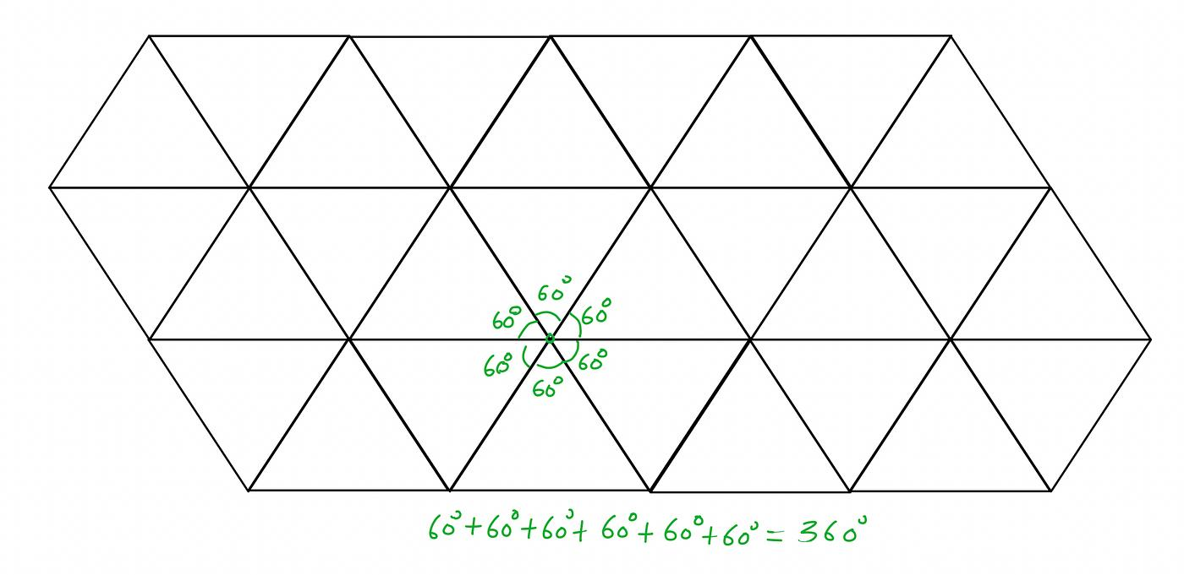
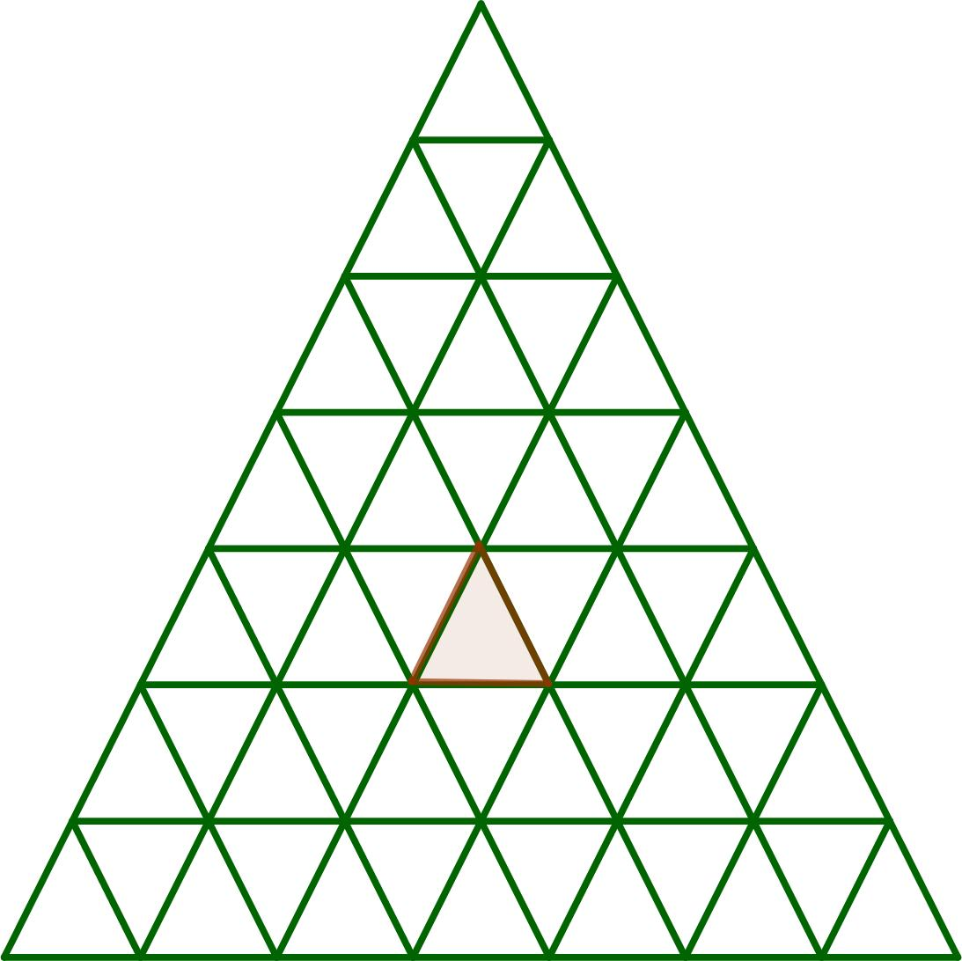
Vertex Configuration
$$\boxed{3.3.3.3.3.3}$$
or simply:
$$\boxed{3^{6}}$$

2. Square Tessellation
# Source: AI Source: Provided by: [Data Path: Persons Table -> ID Column: 1, Name_En Column: Motasem Essam] -> From: [ChatGPT] on [7/25/2026]
A Square Tessellation consists entirely of congruent squares.
Each square has interior angles of:
$${90}^{∘}$$
Four squares meet at every vertex:
$$4\left({90}^{∘}\right)={360}^{∘}$$
Therefore, the squares completely cover the plane.
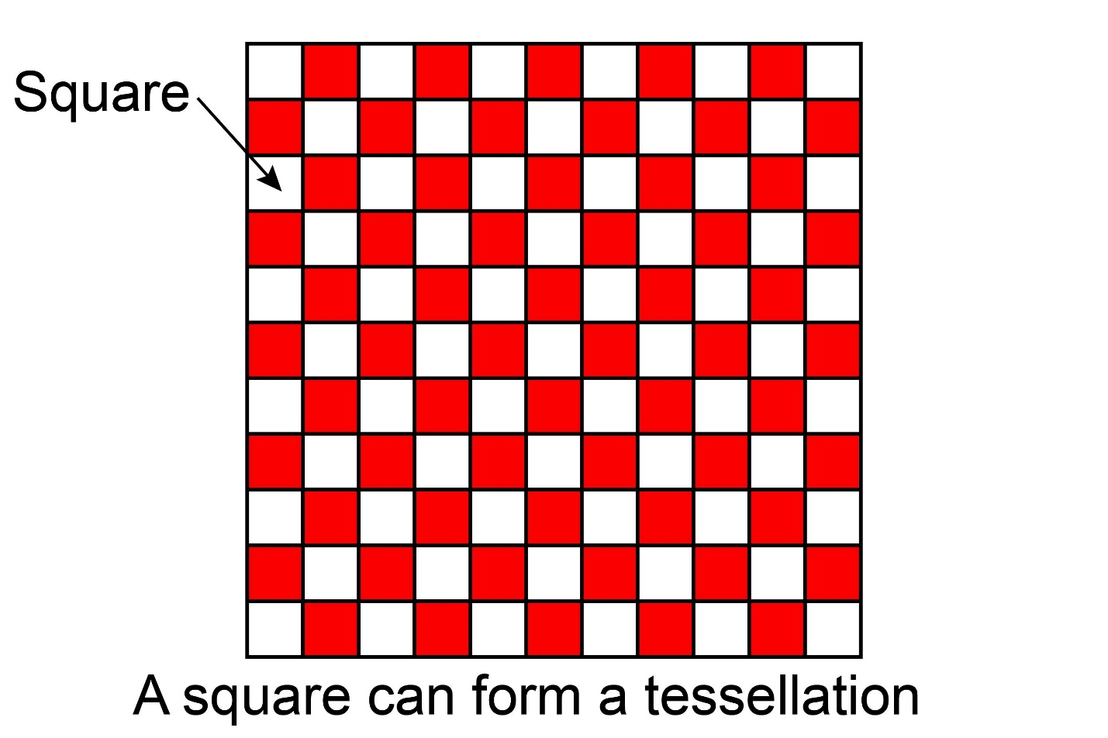
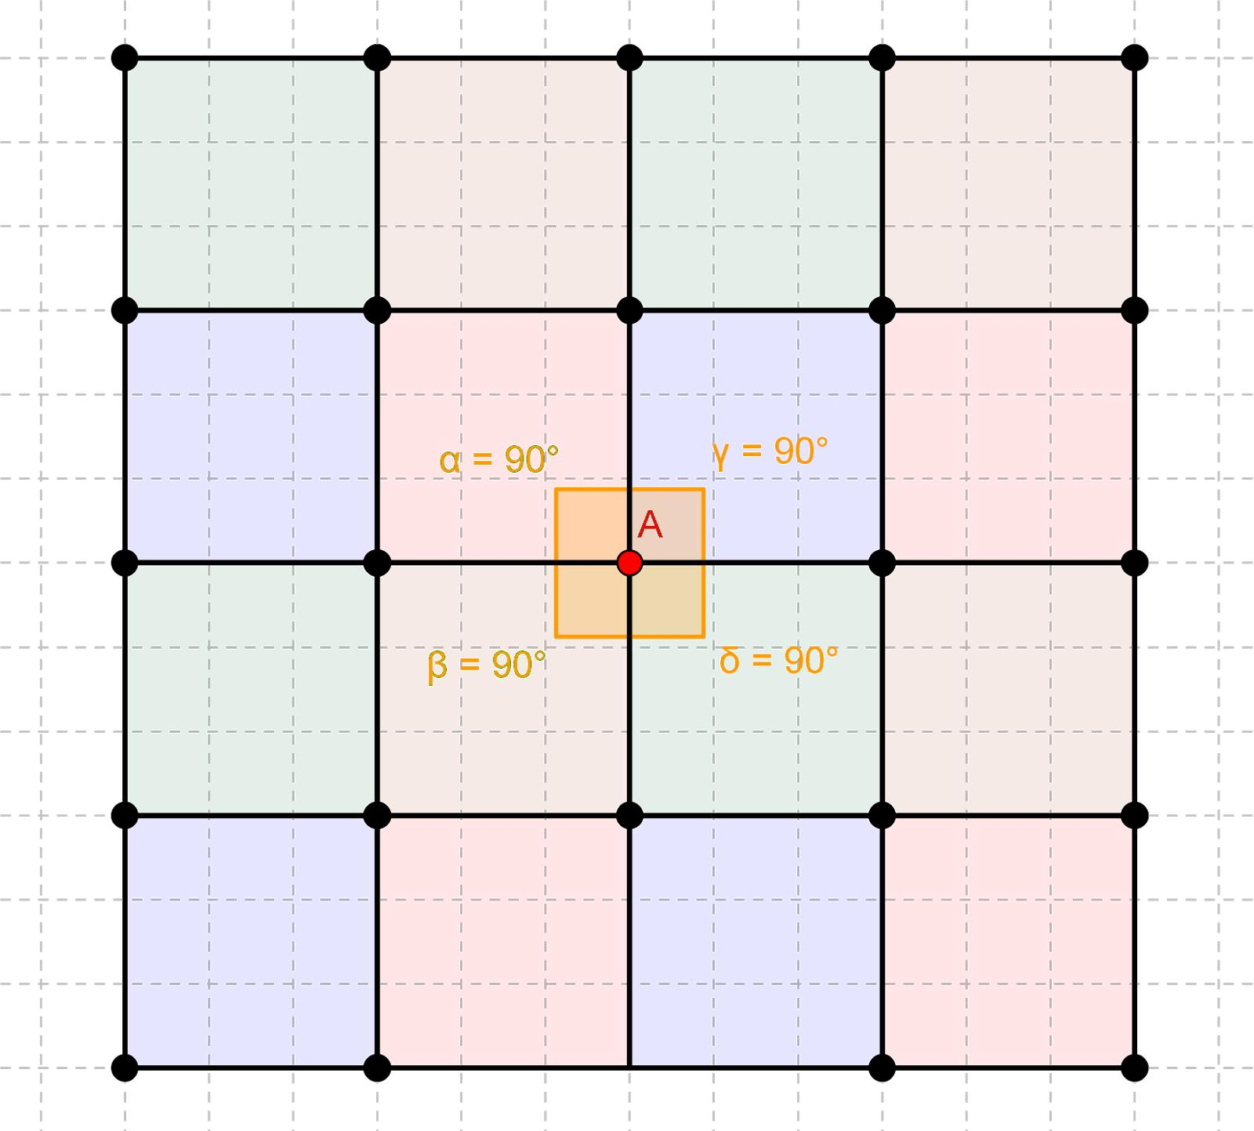
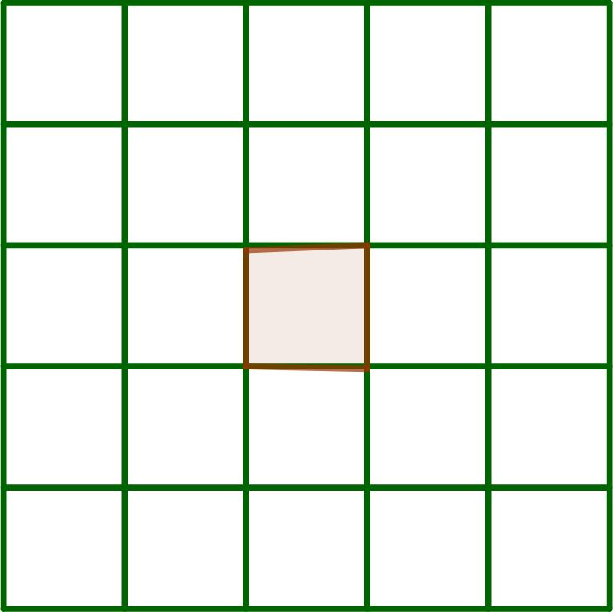
Vertex Configuration
$$\boxed{4.4.4.4}$$
or:
$$\boxed{4^{4}}$$

3. Regular Hexagon Tessellation
# Source: AI Source: Provided by: [Data Path: Persons Table -> ID Column: 1, Name_En Column: Motasem Essam] -> From: [ChatGPT] on [7/25/2026]
A Regular Hexagon Tessellation consists entirely of congruent regular hexagons.
Each regular hexagon has an interior angle of:
$${120}^{∘}$$
Three hexagons meet at every vertex:
$$3\left({120}^{∘}\right)={360}^{∘}$$
Therefore, regular hexagons completely cover the plane.
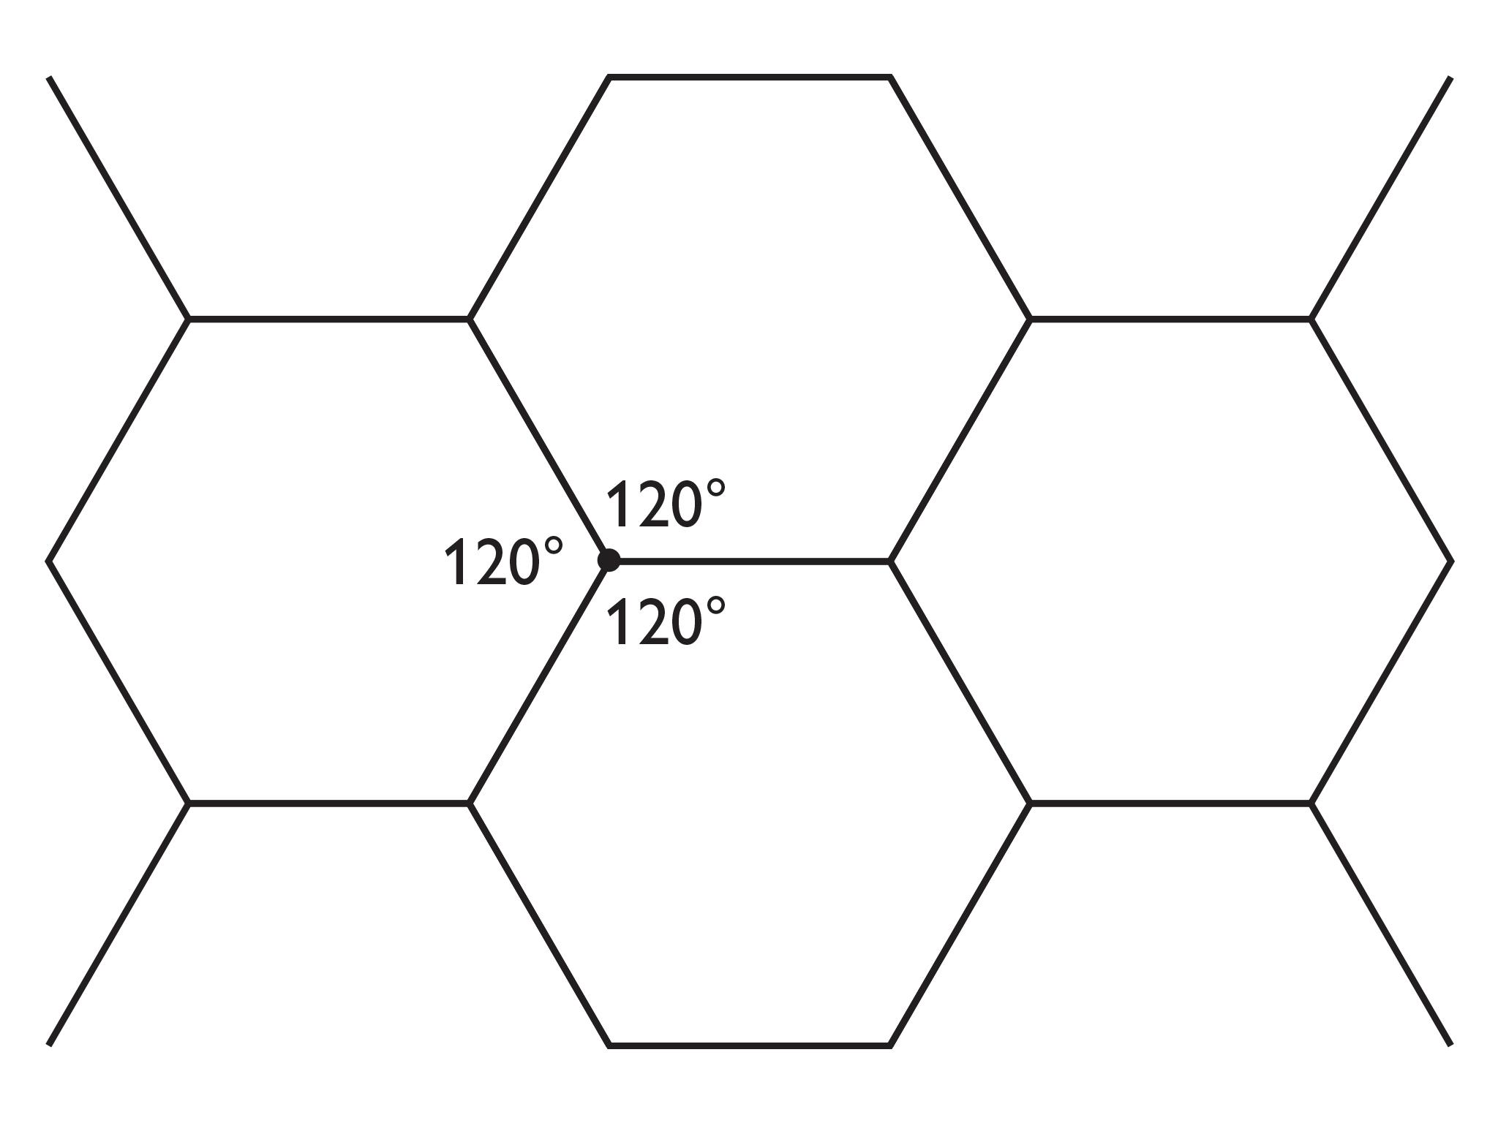
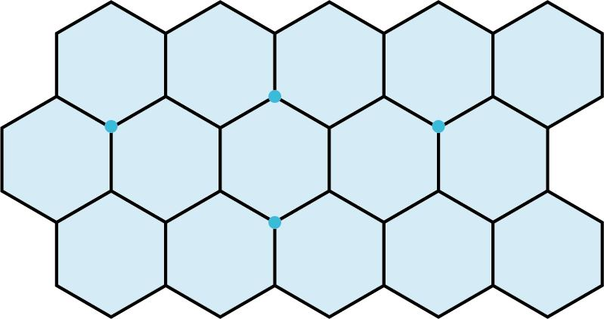
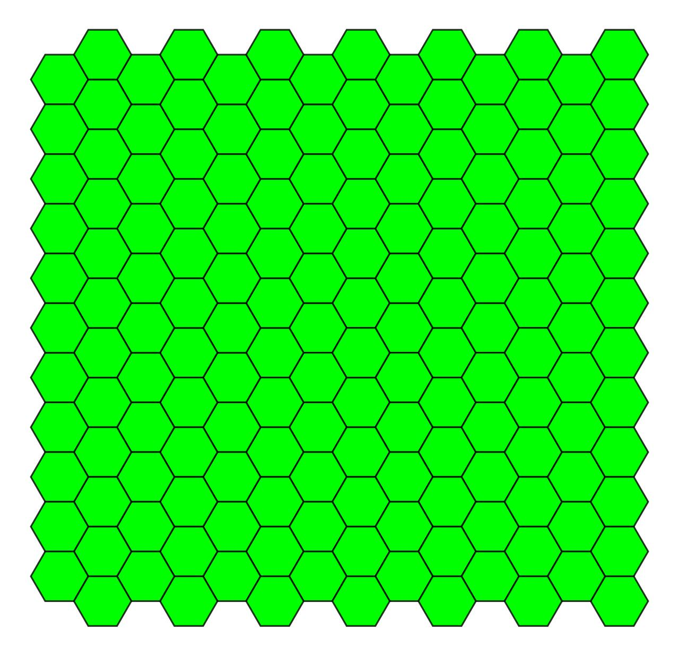

Vertex Configuration
# Source: AI Source: Provided by: [Data Path: Persons Table -> ID Column: 1, Name_En Column: Motasem Essam] -> From: [ChatGPT] on [7/25/2026]
$$\boxed{6.6.6}$$
or:
$$\boxed{6^{3}}$$

Why Are There Only Three?
# Source: AI Source: Provided by: [Data Path: Persons Table -> ID Column: 1, Name_En Column: Motasem Essam] -> From: [ChatGPT] on [7/25/2026]
For a regular polygon with $n$sides, its interior angle is:
$$θ=\frac{\left(n-2\right){180}^{∘}}{n}$$
For a regular tessellation, an integer number $k≥3$of polygons must meet at each vertex:
$$k\frac{\left(n-2\right){180}^{∘}}{n}={360}^{∘}$$
Solving for $k$:
$$\boxed{k=\frac{2n}{n-2}}$$
Testing regular polygons gives:
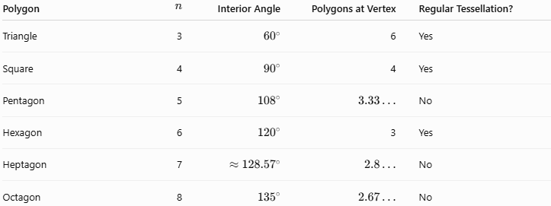
Polygon | $$n$$ | Interior Angle | Polygons at Vertex | Regular Tessellation?
Triangle | 3 | $${60}^{∘}$$ | 6 | Yes
Square | 4 | $${90}^{∘}$$ | 4 | Yes
Pentagon | 5 | $${108}^{∘}$$ | $$3.33…$$ | No
Hexagon | 6 | $${120}^{∘}$$ | 3 | Yes
Heptagon | 7 | $$≈{128.57}^{∘}$$ | $$2.8…$$ | No
Octagon | 8 | $${135}^{∘}$$ | $$2.67…$$ | No
For polygons with more than six sides, the interior angle is greater than ${120}^{∘}$. At least three polygons would therefore exceed ${360}^{∘}$, while two polygons cannot fill the entire ${360}^{∘}$around a vertex.
Thus:
$$\boxed{\text{Exactly three regular tessellations exist.}}$$

Comparison of the Three Regular Tessellations
# Source: AI Source: Provided by: [Data Path: Persons Table -> ID Column: 1, Name_En Column: Motasem Essam] -> From: [ChatGPT] on [7/25/2026]
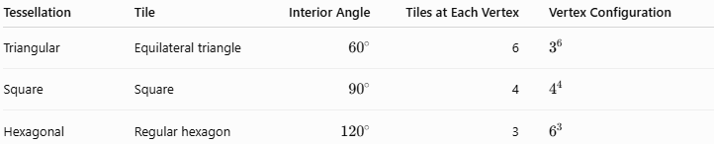
Tessellation | Tile | Interior Angle | Tiles at Each Vertex | Vertex Configuration
Triangular | Equilateral triangle | $${60}^{∘}$$ | 6 | $$3^{6}$$
Square | Square | $${90}^{∘}$$ | 4 | $$4^{4}$$
Hexagonal | Regular hexagon | $${120}^{∘}$$ | 3 | $$6^{3}$$

Symmetry
# Source: AI Source: Provided by: [Data Path: Persons Table -> ID Column: 1, Name_En Column: Motasem Essam] -> From: [ChatGPT] on [7/25/2026]
All three regular tessellations have strong symmetry.
They possess:
- Translational symmetry
- Rotational symmetry
- Reflection symmetry
- Repeating patterns
Their symmetry comes directly from the regular polygons used as tiles.

Important Distinction
# Source: AI Source: Provided by: [Data Path: Persons Table -> ID Column: 1, Name_En Column: Motasem Essam] -> From: [ChatGPT] on [7/25/2026]
A regular tessellation is not simply any tessellation containing regular polygons.
For example, a pattern containing both squares and equilateral triangles is not a regular tessellation, because it uses more than one type of polygon.
Such patterns belong to the study of semi-regular tessellations when they satisfy the appropriate vertex conditions.

Classification
# Source: AI Source: Provided by: [Data Path: Persons Table -> ID Column: 1, Name_En Column: Motasem Essam] -> From: [ChatGPT] on [7/25/2026]
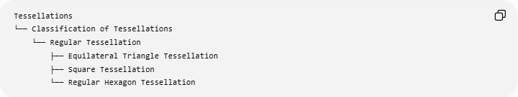
Tessellations
└── Classification of Tessellations
└── Regular Tessellation
├── Equilateral Triangle Tessellation
├── Square Tessellation
└── Regular Hexagon Tessellation

Key Formula
# Source: AI Source: Provided by: [Data Path: Persons Table -> ID Column: 1, Name_En Column: Motasem Essam] -> From: [ChatGPT] on [7/25/2026]
$$\boxed{k=\frac{2n}{n-2}}$$
where:
- $n$= number of sides of the regular polygon
- $k$= number of polygons meeting at each vertex
The only values producing valid regular plane tessellations are:
$$\boxed{\left(n , k\right)=\left(3 , 6\right),\left(4 , 4\right),\left(6 , 3\right)}$$

Key Points
# Source: AI Source: Provided by: [Data Path: Persons Table -> ID Column: 1, Name_En Column: Motasem Essam] -> From: [ChatGPT] on [7/25/2026]
- A regular tessellation uses one type of regular polygon.
- The polygons are congruent and arranged uniformly.
- There can be no gaps or overlaps.
- The angles around each vertex total ${360}^{∘}$.
- There are exactly three regular tessellations:
  - Equilateral triangles
  - Squares
  - Regular hexagons.

